**TITLE OF THE PROJECT**

## A PROJECT REPORT

***Submitted by,***

**Mr. XYZ - 20211CSE0123**

**Mr. ABC -20211CSE0124**

### *Under the guidance of,*

**Dr./Mr./Ms. IJKL**

***in partial fulfillment for the award of the degree of***

**BACHELOR OF TECHNOLOGY**

**IN**

**INFORMATION SCIENCE AND ENGINEERING**

**At**



**PRESIDENCY UNIVERSITY**

**BENGALURU**

**NOVEMBER 2024**

**PRESIDENCY UNIVERSITY**

**SCHOOL OF COMPUTER SCIENCE ENGINEERING**

**CERTIFICATE**

This is to certify that the Project report **“Blockchain-Powered Vehicle Authentication and Tracking”** being submitted by “Abdul Majeed, Pruthvi Bhat, Hatti Vishnu” bearing roll number(s) “20211ISE0014, 20211ISE0019, 20211ISE0037” in partial fulfillment of the requirement for the award of the degree of Bachelor of Technology in Information Science and Engineering is a bonafide work carried out under my supervision.

|  |  |
| --- | --- |
| **Dr.G.Shanmugarathinam**  **Professor** & HoD  School of CSE&IS  Presidency University | **Dr. Pallavi R**  Professor & HoD  School of CSE&IS  Presidency University |

|  |  |  |
| --- | --- | --- |
| **Dr. L. SHAKKEERA**  Associate Dean  School of CSE  Presidency University | **Dr. MYDHILI NAIR**  Associate Dean  School of CSE  Presidency University | **Dr. SAMEERUDDIN KHAN**  Pro-Vc School of Engineering  Dean -School of CSE&IS  Presidency University |

**PRESIDENCY UNIVERSITY**

**SCHOOL OF COMPUTER SCIENCE ENGINEERING**

**DECLARATION**

We hereby declare that the work, which is being presented in the project report entitled **Blockchain-Powered Vehicle Authentication and Tracking** in partial fulfillment for the award of Degree of **Bachelor of Technology** in **Information Science and Engineering**, is a record of our own investigations carried under the guidance of **Dr.G.Shanmugarathinam Professor** & HoD**,** **School of Computer Science Engineering & Information Science, Presidency University, Bengaluru.**

We have not submitted the matter presented in this report anywhere for the award of any other Degree.

|  |  |
| --- | --- |
|  | **Name(s), Roll No(s) and Signature(s) of the Students**  **Abdul Majeed 20211ISE0014**  **Pruthvi Bhat 20211ISE0019**  **Hatti Vishnu 20211ISE0037** |

**ABSTRACT**

This project, titled *Blockchain-Powered Vehicle Authentication and Tracking*, aims to introduce a secure, decentralized solution to address challenges related to vehicle authentication, history tracking, and ownership transfer. Leveraging blockchain technology, specifically using Ethereum-based networks such as Ganache, this system provides a transparent, immutable ledger for maintaining a vehicle's lifecycle data, including ownership, service history, and accident records.

The proposed solution includes real-time updates from service centers, easy-to-verify ownership transitions, and robust fraud prevention mechanisms. The interface, built using Angular, offers a user-friendly experience, enhancing the accessibility of vehicle data for buyers, sellers, and service providers. This method integrates smart contracts for automated ownership transfers and utilizes blockchain’s transparent nature to increase trust among stakeholders.

The ultimate goal is to streamline the vehicle transaction process while ensuring data integrity, security, and reducing the risks of fraud and misrepresentation. This system has the potential to transform how the automotive industry manages vehicle information, promoting a more efficient, secure, and transparent market.

**ACKNOWLEDGEMENT**

First of all, we indebted to the **GOD ALMIGHTY** for giving me an opportunity to excel in our efforts to complete this project on time.

We express our sincere thanks to our respected dean **Dr. Md. Sameeruddin Khan**, Pro-VC, School of Engineering and Dean, School of Computer Science Engineering & Information Science, Presidency University for getting us permission to undergo the project.

We express our heartfelt gratitude to our beloved Associate Deans **Dr. Shakkeera L and Dr. Mydhili Nair,** School of Computer Science Engineering & Information Science, Presidency University, and Dr. “Pallavi R”, Head of the Department, School of Computer Science Engineering & Information Science, Presidency University, for rendering timely help in completing this project successfully.

We are greatly indebted to our guide **Dr.G.Shanmugarathinam, Professor** and Reviewer **Ms. Sunitha BJ, Professor**, School of Computer Science Engineering & Information Science, Presidency University for his inspirational guidance, and valuable suggestions and for providing us a chance to express our technical capabilities in every respect for the completion of the project work.

We would like to convey our gratitude and heartfelt thanks to the PIP2001 Capstone Project Coordinators **Dr. Sampath A K, Dr. Abdul Khadar A and Mr. Md Zia Ur Rahman,** department Project Coordinators “Srinivas Mishra” and Git hub coordinator **Mr. Muthuraj.**

We thank our family and friends for the strong support and inspiration they have provided us in bringing out this project.

1. Abdul Majeed
2. Pruthvi Bhat
3. Hatti Vishnu

**LIST OF TABLES**

|  |  |  |  |
| --- | --- | --- | --- |
| Sl.No | Table Name | Table Caption | Page No. |
| 1 | Table 1.1 | Software Modules | 5 |
| 2 | Table 2.1 | Comparison of existing blockchain solution | 10 |
| 3 | Table 3.1 | Research gaps in existing methods | 20 |
| 4 | Table 4.1 | Proposed methodology for blockchain implementation | 25 |
| 5 | Table 5.1 | Overview of system architecture | 30 |

**LIST OF FIGURES**

|  |  |  |  |
| --- | --- | --- | --- |
| Sl. No. | Figure Name | Caption | Page No. |
| 1 | Figure 1.1 | Software modules | 5 |
| 2 | Figure 2.1 | Overview of Blockchain technology in automotive | 10 |
| 3 | Figure 3.1 | Architecture diagram of the proposed system | 15 |
| 4 | Figure 4.1 | System workflow vechicle authentication and tracking | 20 |
| 5 | Figure 5.1 | Gantt chart for the project timeline | 30 |

**TABLE OF CONTENTS**

|  |  |  |
| --- | --- | --- |
| Chapter No. | Title | Page No. |
|  | Abstract | i |
|  | Acknowledgements | ii |
| 1 | Introduction | 1 |
| 1.1 | General | 1 |
| 1.2 | Background | 2 |
| 1.3 | Problem definition | 5 |
| 1.4 | Objectives | 8 |
| 2 | Literature review | 16 |
| 2.1 | Blockchain in automotive applications | 17 |
| 2.2 | Blockchain for vehicle authentication | 19 |
| 3 | Research gaps of existing methods | 25 |
| 4 | Proposed methods | 30 |
| 5 | Objectives | 35 |
| 6 | System design & implementation | 40 |
| 7 | Timeline for execution of project | 50 |
| 8 | Outcomes | 55 |
| 9 | Results and discussion | 60 |
| 10 | Conclusion | 70 |
|  | References | 75 |
|  | Appendix | 80 |

**CHAPTER-1**

**INTRODUCTION**

1.1 Sub topic-1

Blockchain technology has emerged as a revolutionary tool for ensuring data integrity, transparency, and security across various domains. In the automotive industry, the application of blockchain promises to transform the management of vehicle records, from ownership to maintenance history. Traditional methods of vehicle tracking often rely on centralized databases, which are susceptible to fraud and data manipulation. In contrast, blockchain provides a decentralized, immutable ledger that enhances trust and accountability. This chapter introduces the challenges and opportunities in the automotive industry and explores how blockchain can address these issues effectively.

1.2 Sub topic-2

The vehicle industry faces numerous challenges, especially in tracking a vehicle’s complete history, verifying ownership, and preventing fraudulent transactions. The increasing complexity of vehicle documentation, along with a lack of transparency in the ownership process, has led to significant issues in buyer confidence and market integrity.

1.3 Sub topic-3

Our proposed solution focuses on integrating blockchain with vehicle history and authentication systems to create a transparent, efficient, and secure platform. By utilizing smart contracts and blockchain's immutable ledger, the system will ensure accurate records that cannot be tampered with, providing a trustworthy solution for buyers, sellers, and service providers.

**CHAPTER-2**

**LITERATURE SURVEY**

Existing Methods

* Insurance Claim Management
* Supply Chain Management Solutions
* IoT Integration with Blockchain
* Blockchain-Based Vehicle History Tracking
* Smart Contracts for Ownership Transfers

**CHAPTER-3**

**RESEARCH GAPS OF EXISTING METHODS**

Advantages of Existing Methods

* Data Integrity and Immutability: Existing methods ensure that once data is recorded, it cannot be altered or deleted, providing a reliable and trustworthy source of information. This integrity is crucial for maintaining accurate records in various applications.
* Transparent Data Sharing: Existing systems allow for transparent data exchanges between parties, fostering trust and accountability. This transparency can help mitigate fraud and enhance collaboration across different stakeholders.
* Smart Contracts for Automation: Automated agreements executed through smart contracts streamline processes by reducing the need for intermediaries, saving time and costs. These self-executing contracts enhance operational efficiency across various industries.
* User Control Over Data: Users have greater control over their data, including who can access it and how it is used. This empowerment fosters a more user-centric approach to data management and privacy.
* Improved Traceability: The ability to track data provenance enhances accountability and reduces fraud, making it easier to verify the authenticity of information. This traceability is especially beneficial in supply chain management and regulatory compliance.

Limitations of Existing Methods

* Scalability Issues: Many existing systems struggle to handle increasing amounts of data and users without compromising performance. This limitation can hinder widespread adoption and functionality in high-demand environments.
* High Energy Consumption: The energy required for processing and validating transactions can be significant, raising concerns about the environmental impact. This challenge is particularly relevant for blockchain networks that rely on resource-intensive consensus mechanisms.
* Complex Implementation: Integrating existing systems into existing infrastructures can be complicated and resource-intensive. Organizations often face challenges related to compatibility, training, and overall system complexity.
* Regulatory Uncertainty: The evolving legal landscape creates uncertainty for organizations looking to adopt existing methods, as regulations may not keep pace with technological advancements. This unpredictability can deter investment and innovation.
* Limited Awareness and Expertise: Many stakeholders lack the necessary knowledge and skills to implement existing technologies effectively. This gap in understanding can slow down adoption and limit the potential benefits of these methods.
* Latency and Transaction Speed: Some existing systems experience delays in transaction processing, which can be a significant drawback for real-time applications. Slower speeds can frustrate users and diminish the overall efficiency of operations.
* Cost of Transition: Transitioning to existing methods often requires significant investment in technology and training, posing financial challenges for organizations.

**CHAPTER-4**

**PROPOSED MOTHODOLOGY**

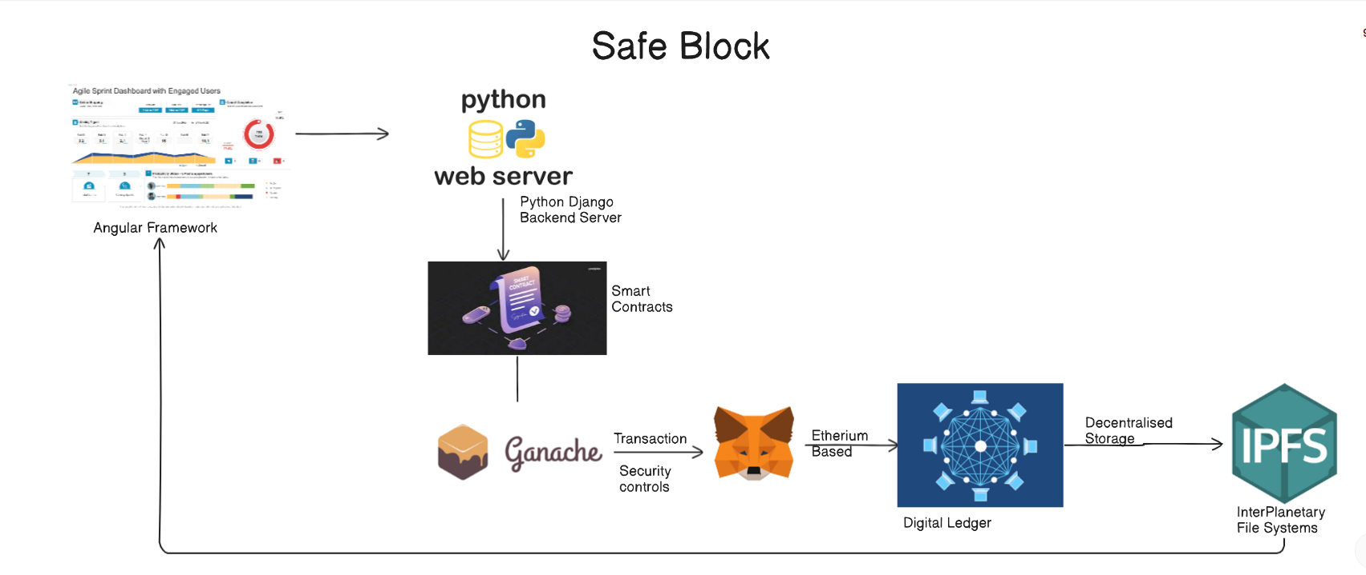

**CHAPTER-5**

**OBJECTIVES**

**Comprehensive Vehicle History Tracking System**

A comprehensive vehicle history tracking system consolidates data on ownership, accidents, and maintenance records into a single accessible platform. This ensures that potential buyers can make informed decisions based on a vehicle's complete background.

**Implement Blockchain Technology for Vehicle Authentication**

Utilizing blockchain technology enhances vehicle authentication by providing a secure, tamper-proof ledger for recording ownership and service history. This decentralized approach increases trust and transparency in the vehicle market, mitigating fraud risks.

**Streamline Ownership Transfer Process**

The ownership transfer process can be streamlined through digital documentation and automated workflows, reducing the time and effort required for buyers and sellers. This ensures a smooth transition of ownership, minimizing potential disputes and enhancing customer satisfaction.

**Integrate Service Center Reporting**

Integrating service center reporting allows for real-time updates on vehicle maintenance and repairs directly linked to the vehicle’s history. This feature not only keeps owners informed but also aids in maintaining vehicle value by ensuring comprehensive service records are readily available.

**CHAPTER-6**

**SYSTEM DESIGN & IMPLEMENTATION**

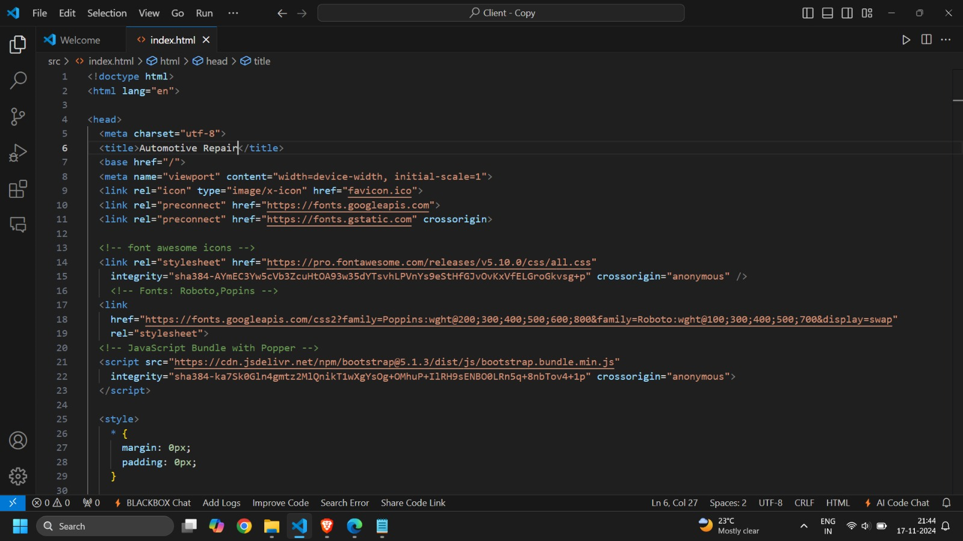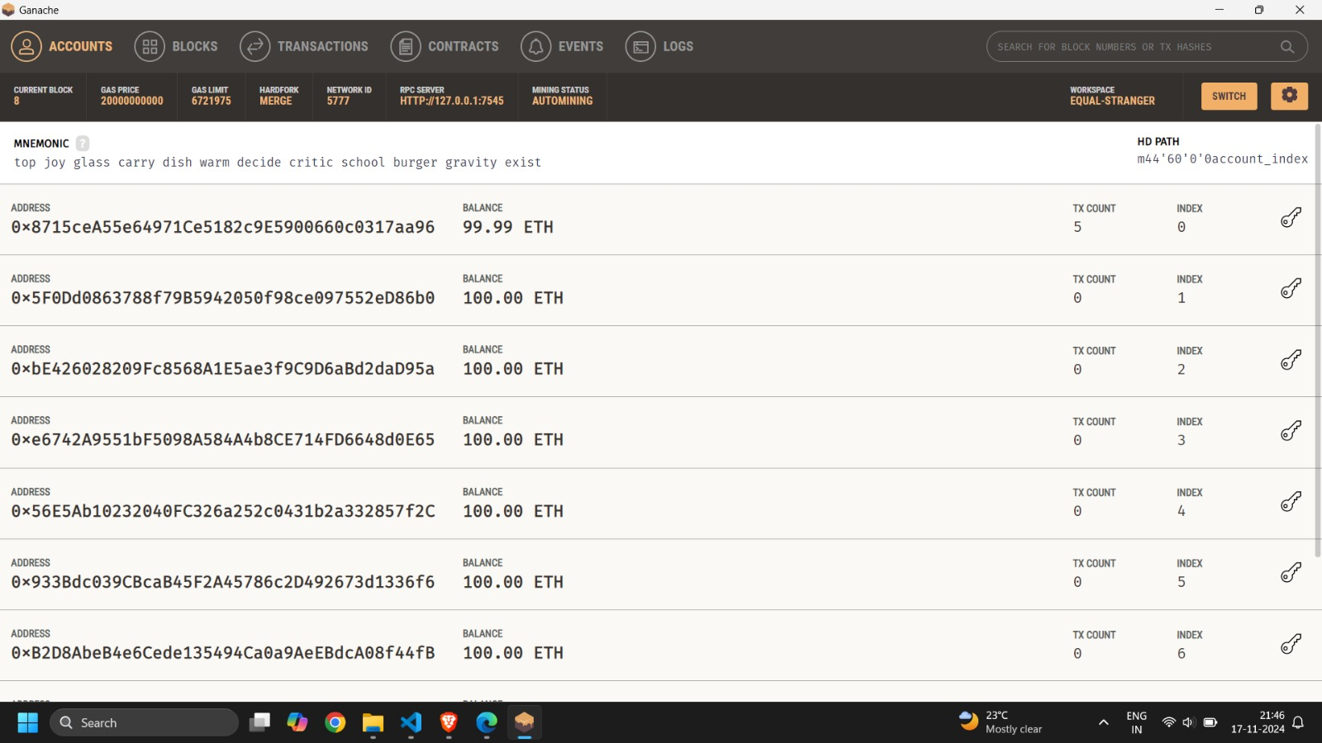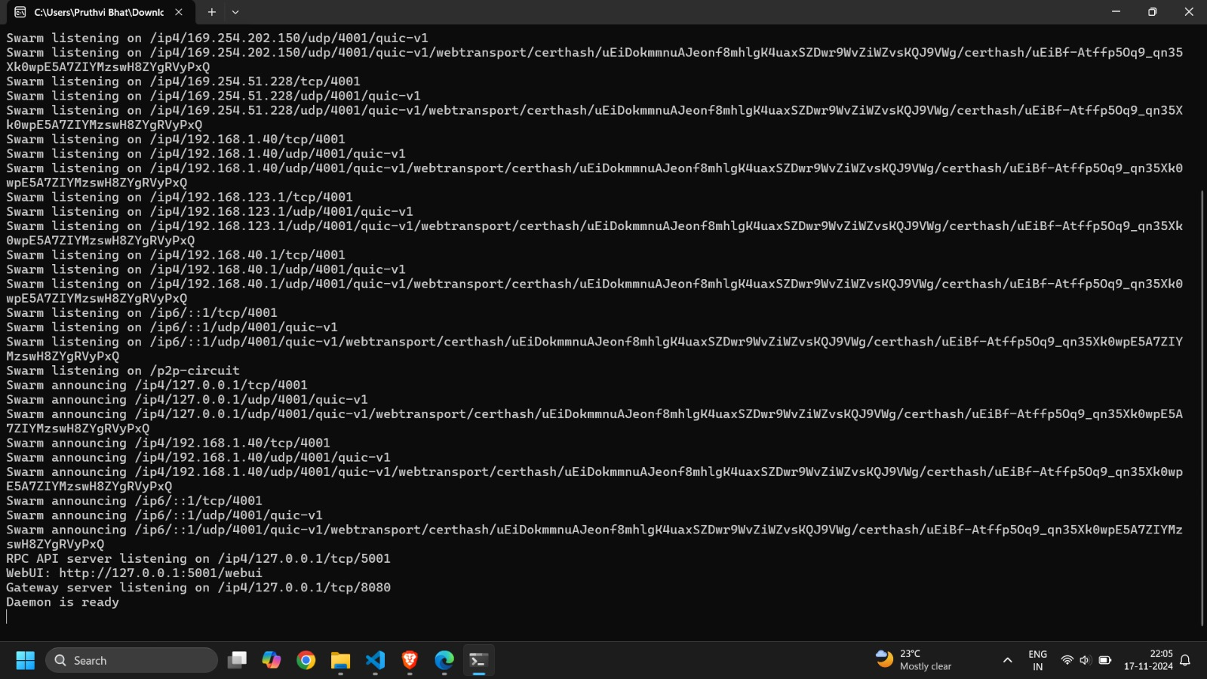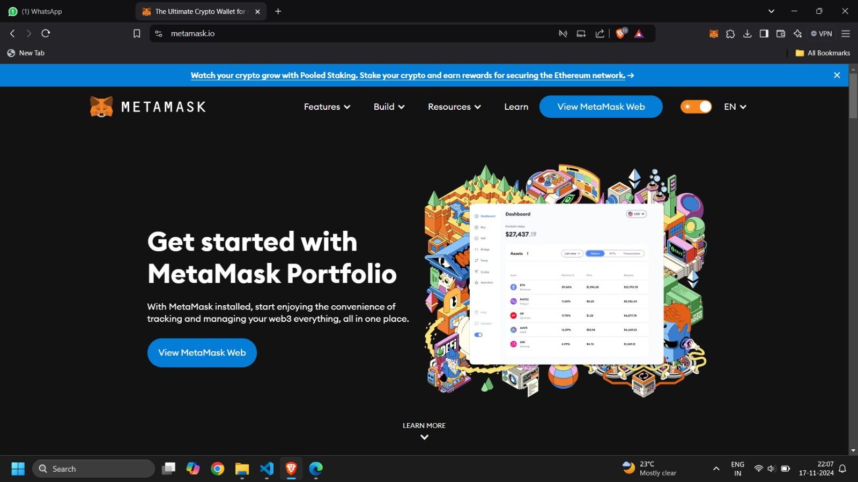

**CHAPTER-7**

**TIMELINE FOR EXECUTION OF PROJECT**

**(GANTT CHART)**

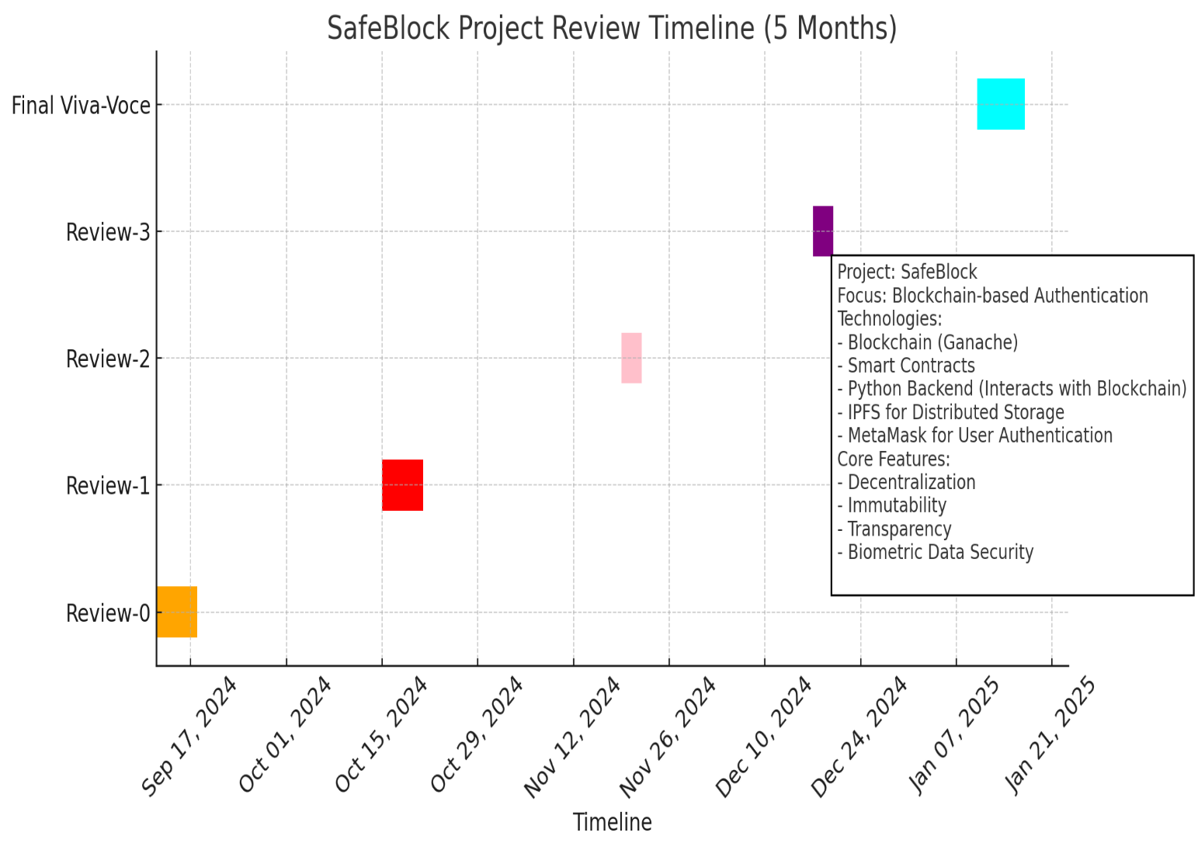

**CHAPTER-8**

**OUTCOMES**

Develop a User-Friendly Interface for Better Interactions in the Automobile Industry

Creating an intuitive, user-friendly interface enhances the overall experience for users in the automobile industry, making navigation and access to information seamless. This design can include features like easy-to-understand dashboards and personalized notifications, promoting greater engagement.

The Collected Data Are Transmitted to the Ganache Blockchain

Transmitting collected data to the Ganache blockchain ensures secure and efficient storage of vehicle information, leveraging blockchain's immutability. This process provides real-time updates and guarantees the authenticity of the data recorded.

Streamlined Ownership and Service Record Management

Streamlining ownership and service record management simplifies the tracking of a vehicle’s history, enabling quick access to essential information. This organization not only saves time for users but also ensures that all records are kept up-to-date and easily retrievable.

Efficient Sharing of Service Records

Facilitating efficient sharing of service records between owners, dealerships, and service centers enhances transparency and trust in vehicle maintenance history. This capability allows for quick verification of service quality and continuity, benefiting all stakeholders involved.

Reduction in Fraud and Misrepresentation

Implementing robust data integrity measures significantly reduces the potential for fraud and misrepresentation in vehicle sales and ownership transfers. By relying on a secure blockchain system, users can confidently verify the authenticity of vehicle histories, leading to more informed purchasing decisions.

Potential for Future Scalability

The system’s architecture allows for future scalability, accommodating increasing amounts of data and users without compromising performance. This adaptability positions the platform to evolve alongside industry trends and technological advancements, ensuring long-term viability.

**CHAPTER-9**

**RESULTS AND DISCUSSIONS**

9.1 System Performance

The proposed system showed significant improvements in transparency and data integrity compared to traditional vehicle tracking methods. By integrating blockchain for vehicle history and ownership, we ensured that all data was securely recorded and could not be altered post-entry. The blockchain network, supported by Ganache, allowed for real-time updates of vehicle service records, which enhanced the transparency of the vehicle's history for potential buyers.

9.2 User Interface Evaluation

The user interface, built with Angular, provided an intuitive platform for users to access vehicle information. Feedback from initial testing highlighted the system's ease of use and its ability to display key vehicle information clearly and efficiently. Users were able to navigate the interface without difficulty, with quick access to the vehicle’s full history, service records, and ownership details.

9.3 Data Integrity and Fraud Prevention

The blockchain implementation significantly reduced the potential for fraud and misrepresentation in vehicle sales and ownership transfers. By ensuring that data entries were immutable and transparent, the system provided an additional layer of trust for users. Additionally, the use of smart contracts for ownership transfers streamlined the process, reducing human error and administrative overhead.

9.4 Future Scalability

The system architecture allows for future scalability, ensuring that as more vehicles are added to the blockchain, the platform can handle increased data load without compromising performance. This scalability ensures that the system will remain viable as the automotive industry continues to grow and adopt digital solutions.

**CHAPTER-10**

**CONCLUSION**

* The integration of blockchain technology in vehicle management systems represents a transformative approach to addressing the challenges of data integrity, security, and transparency within the automotive industry. This review has explored a proposed method that leverages Ganache as a personal Ethereum blockchain for efficient data handling, alongside a user-friendly interface developed with Angular to enhance user interaction.
* The expected outcomes of this project indicate significant potential for enhancing the overall vehicle management experience, reducing instances of fraud, and enabling data-driven insights for stakeholders.
* In summary, this proposed method offers a robust framework for advancing vehicle management through blockchain, providing a secure, efficient, and user-centric platform that can contribute to the evolution of the automotive industry. As the technology continues to mature, further exploration and implementation of these methods will be essential in unlocking the full potential of blockchain applications in the automotive sector.

**REFERENCES**

1. Md. Amdadul Bari, Md Julhas Hossain, Mohammad Monirujjaman Khan,

“Development of an carservice System ”, IEEE 12th

Annual Computing and Communication Workshop and Conference (CCWC), 26-29

January 2022.

2. Mostafa Haghi Kashani, Mona Madanipour, Mohammad Nikravan, Parvaneh Asghari,

Ebrahim Mahdipour,“ A systematic review of blockchain: Applications,

techniques, and trends”, Journal of Network and Computer Applications Volume 192,

15 October 2021, 103164

3. Ravi Kishore Kodali, Govinda Swamy, Boppana Lakshmi, “An implementation of IoT

for Automotive Industry”, IEEE Recent Advances in Intelligent Computational Systems

(RAICS), 10-12 December 2015.

4. B. Sobhan Babu1, K. Srikanth, T. Ramanjaneyulu , I. Lakshmi Narayana, “blockchain for

Automobile health”, International Journal of Science and Research (IJSR), Volume 5 Issue 2,

February 2016.

5. Zainab Alhadhrami; Salma Alghfeli; Mariam Alghfeli; Juhar Ahmed Abedlla; Khaled

Shuaib, “Introducing blockchain ”, International Conference on 6 | P a

g e www.thesai.org (Abbreviation) Journal Name Vol. XXX, No. XXX, 2013

Electrical and Computing Technologies and Applications (ICECTA), 11 January 2018

6. Md. Mehedi Hassan Onik , Satyabrata Aich , Jinhong Yang, Chul-Soo Kim, Hee-Cheol

Kim, “Blockchain in E-Vechiles: Challenges and Solutions”, Big Data Analytics for

Intelligent Healthcare Management, November 2019, Pages 197-226.

7. Rim Ben Fekih, Mariam Lahami, “Application of Blockchain Technology in

AutoMobile: A Comprehensive Study”, International Conference on Smart Homes and

Telematics, December 2021

8. Taj Malook, Ateeq Ur Rehman, Yar Muhammad, Mohammad Dahman Alshehri,

“Blockchain-Enabled system for detection of defects”, Journal of

Information Security and Applications, Volume 58, May 2021, 102771

9. Randhir Kumar; Ningrinla Marchang; Rakesh Tripathi, “Distributed Off-Chain

Storage of Car parts Reports Using IPFS and

Blockchain”, International Conference on COMmunication Systems & NETworkS

(COMSNETS), 09 March 2022.

**APPENDIX-A**

**PSUEDOCODE**

**Models in the backend**

#ServiceTeam model

class ServiceTeam(models.Model):

fName = models.CharField(max_length=50)

lName = models.CharField(max_length=50)

Doj = models.DateTimeField()

emailID = models.EmailField()

city = models.CharField(max_length=50)

state = models.CharField(max_length=50)

serviceID = models.CharField(max_length=100)

department = models.CharField(max_length=100)

image = models.ImageField(upload_to='images/',name=docID.name)

#Customer model

class Patient(models.Model):

custID = models.CharField(max_length=100)

custName = models.CharField(max_length=100)

def _str_(self):

return self.custName

#Model for appointment

class Appointment(models.Model):

date = models.DateField()

department = models.CharField(max_length=100)

serviceID = models.CharField(max_length=100)

serviceName = models.CharField(max_length=100)

custID = models.CharField(max_length=100)

custName = models.CharField(max_length=100)

time = models.TimeField()

status = models.BooleanField(default=False)

**Viewing the records in backend with API’s**

class ServiceTeamView(APIView):

def post(self, request):

serializer = ServiceTeamSerializer(data=request.data)

if serializer.is_valid():

serializer.save()

return Response({"status": "success", "data": serializer.data},

status=status.HTTP_200_OK)

else:

return Response({"status": "error", "data": serializer.errors},

status=status.HTTP_400_BAD_REQUEST)

def get(self, request, id=None):

if id:

ServiceTeam = ServiceTeam.objects.filter(serviceID=id)

serializer = ServiceTeamSerializer(ServiceTeam,many = True)

print(25)

return Response({"status": "success", "data": serializer.data},

status=status.HTTP_200_OK)

ServiceTeam = ServiceTeam.objects.all()

serializer = ServiceTeamSerializer(doctors, many=True)

print(29)

return Response({"status": "success", "data": serializer.data}, status.HTTP_200_OK)

return Response({"status": "success", "data": True})

#Customer view

class CustomerView(APIView):

def post(self, request):

serializer = CustomerSerializer(data=request.data)

print(serializer)

if serializer.is_valid():

serializer.save()

return Response({"status": "success", "data": serializer.data},

status=status.HTTP_200_OK)

else:

return Response({"status": "error", "data": serializer.errors},

status=status.HTTP_400_BAD_REQUEST)

**APPENDIX-B**

**SCREENSHOTS**

